A Few Starting Guidelines

- Don’t run before you can walk!
- Plant only the vegetables you like to eat!
- Don’t plant it if you don’t know anything about it!
- Successful gardens require an abundance of sunshine
  - 6-8 hours per day
Seeds vs. Plants

Seed Advantages | Seed Disadvantages
- Relatively inexpensive  - Maximum numbers of plants can be obtained from seed  - Can grow cultivars and varieties which may not be available locally  - Can avoid the problem of purchasing diseased plants  - With proper storage, seeds can last several years and can be re-used | - Some seeds require additional preparation before planting, e.g. soaking, scarification, etc.  - Can be washed away by a heavy rain  - Seeds and developing seedlings can be eaten by birds, rodents, insects, etc.  - Danger of transplant shock if you start seeds indoors

Planting from Seeds

- Seeds should be clean and disease-free!
  - Some diseases, such as black rot of cabbage, can attach to the seed coat
  - Others, like blackleg, are carried inside the seed of plants such as cabbage and cauliflower
  - Fungicides present on the seed coats of corn, cucumbers and melon can harm the germinating plants
- Seeds are classified by kind, cultivar, and strain
  - Kind – seeds from plants of a single vegetable, such as corn, carrot, or tomato
  - Cultivar – different varieties of a single kind, generally differing in one or more features

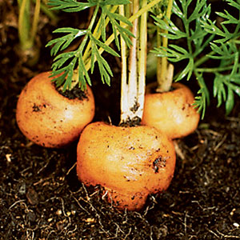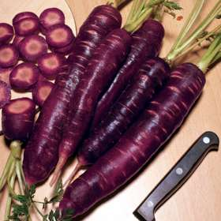
Carrot, Thumbelina
Carrot, Purple Dragon
  - Strain -- different varieties of a single cultivar
    - Dickinson Field Pumpkin is the cultivar used in most commercial pumpkin pie mixes
    - “Libby Select” is the strain selected for correct thickness and color of the edible flesh
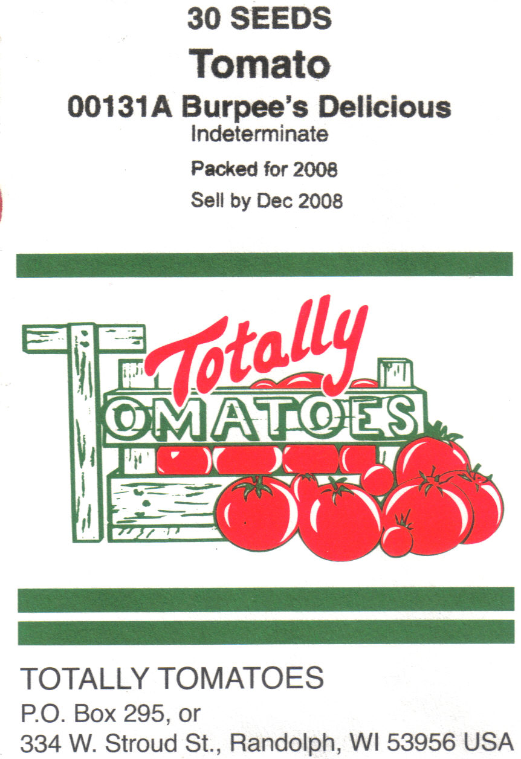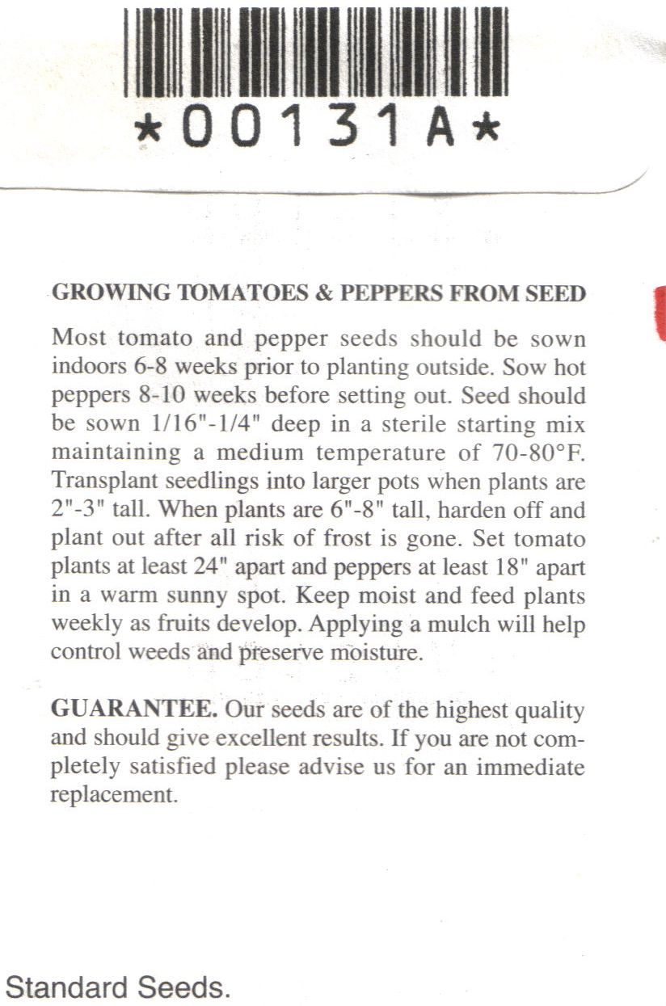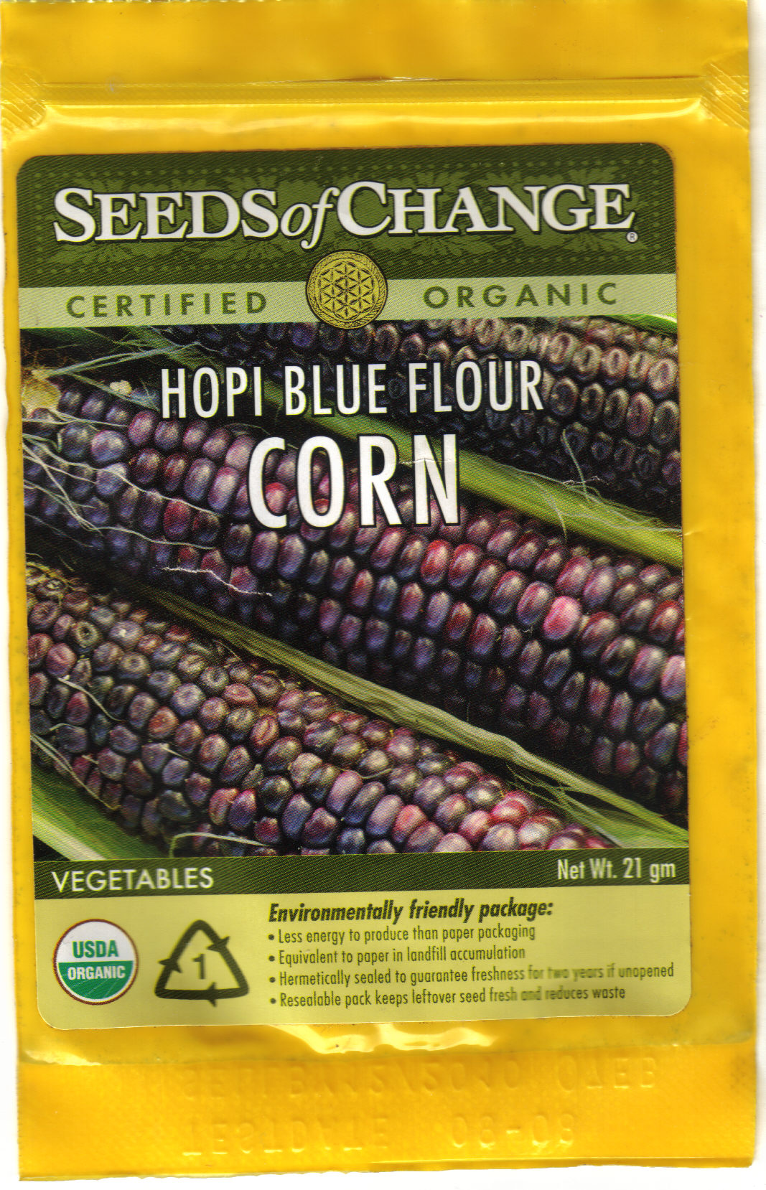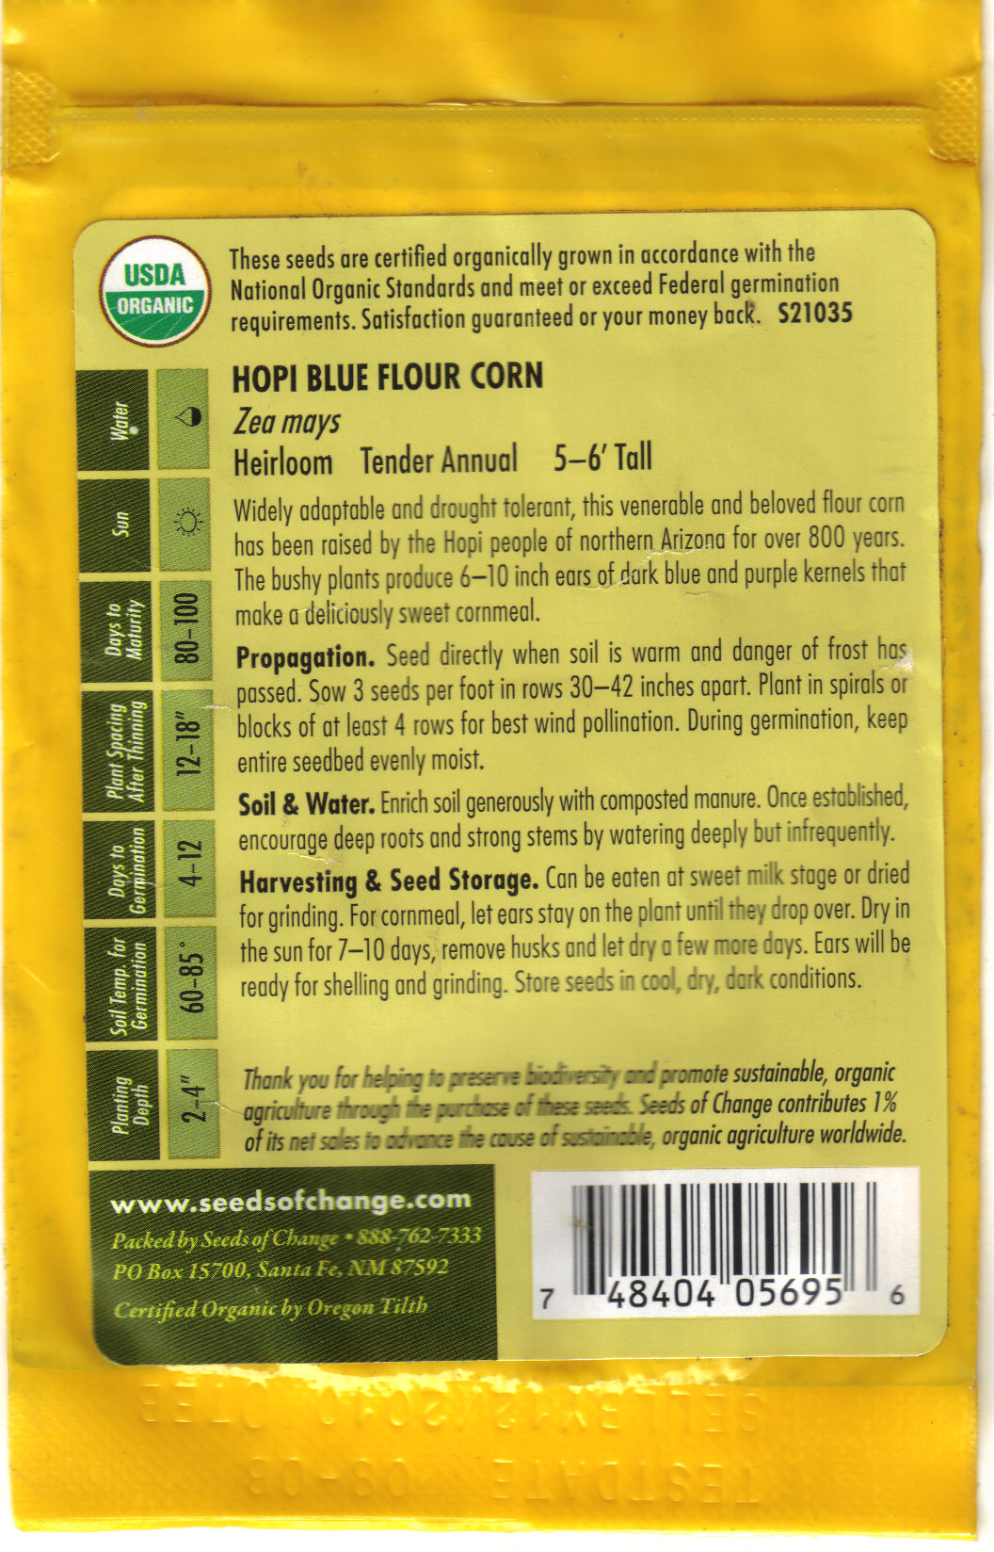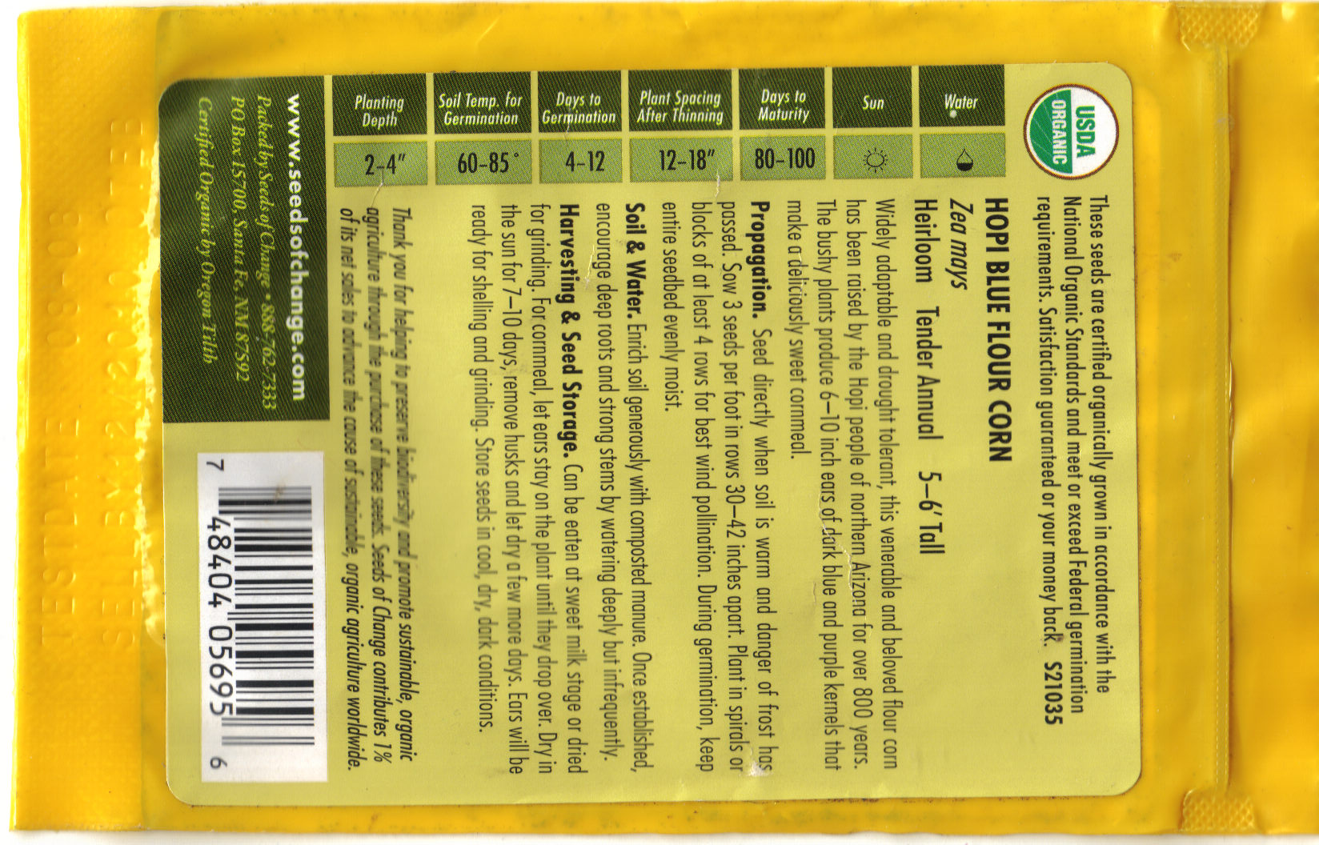
Kind
Cultivar
Packaging and Sell by Dates
Cultivar
Organic
Designation
Kind
Vegetative Propagation
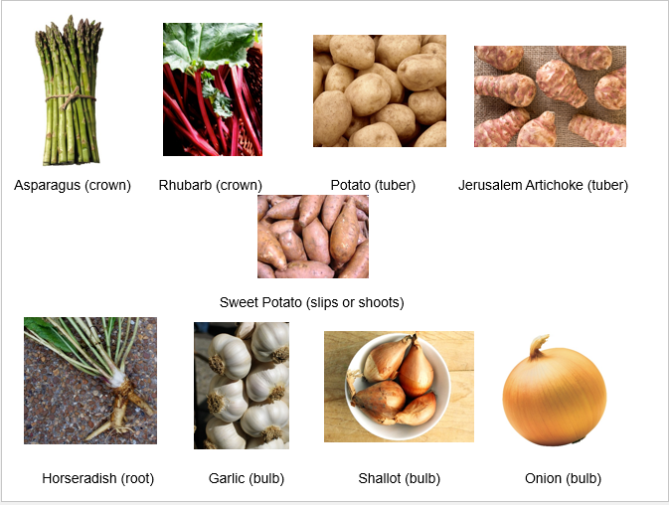
Advantages and Disadvantages of Vegetative Propagation

Advantages | Disadvantages
- The offspring are genetically identical, which allows for preservation of advantageous traits  - Because only one parent is required, it eliminates the need for special mechanisms such as pollination  - Tubers, bulbs, roots, etc. are better able to withstand unfavorable conditions than seeds  - Plants that do not produce viable seeds (potatoes, asparagus, garlic, horseradish, etc.) can be more easily reproduced | - Plants can lose vigor, as there is no genetic variation. As a result, they are more susceptible to species-specific diseases that can destroy the whole crop (e.g. potato blight)  - Vegetative propagation produces large numbers of plants, which can result in overcrowding and lack of nutrients

Where Should I Locate the Garden?

Locate your garden where it will get at least 6 hours of sun per day! The optimum conditions to achieve this are on the south side of the house.
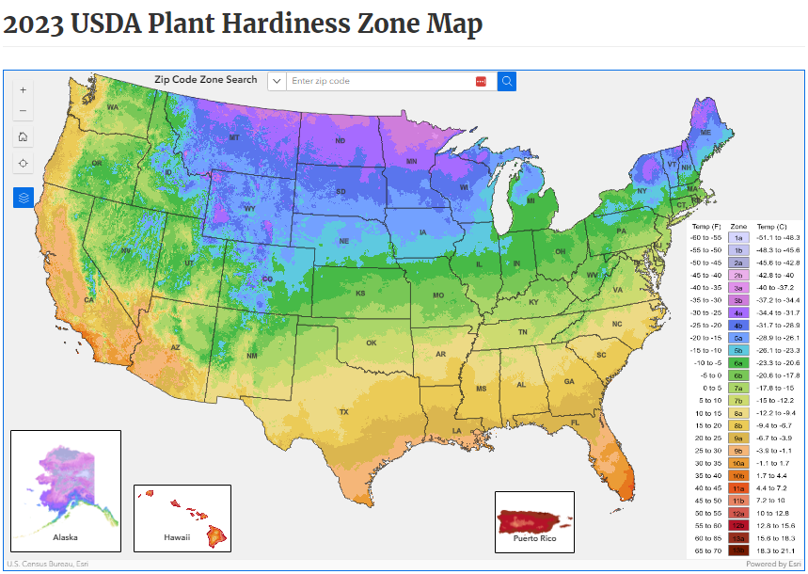
Average First and Last Frost Dates
for Illinois

City | Spring | Fall
Aledo | 4/29 | 10/14
Cairo | 4/8 | 10/26
Chicago | 4/17 | 11/1
East St. Louis | 4/14 | 10/21
Peoria | 4/23 | 10/18
Rockford | 4/30 | 10/12
Springfield | 4/20 | 10/17
Windsor | 4/22 | 10/17
Source: "The Old Farmers Almanac -- https://www.almanac.com/gardening/frostdates
Average First and Last Frost Dates
for Missouri

City | Spring | Fall
Columbia | 4/12 | 10/25
Independence | 4/16 | 10/22
Joplin | 4/16 | 10/21
Kansas City | 4/10 | 10/29
Springfield | 4/10 | 10/22
St. Joseph | 4/25 | 10/10
St. Louis | 4/12 | 10/22
Planning the Garden
Source: "The Old Farmers Almanac -- https://www.almanac.com/gardening/frostdates

- Review last year’s garden
- Decide what you want to plant this year
- Consider space available
- Can you make use of other areas?
- Tried and true vs. something new
- Research before you plant
- Sketch out your garden plan
Guideline for Vegetable Planting Times

Vegetable Planting Classification | Description | Planted from Seed | Planted Vegetatively
Very Hardy Vegetables | Can be planted in the spring, 4-6 weeks before the average date of the last frost | - Collards  - Kale  - Kohlrabi  - Lettuce  - Onions  - Peas  - Rutabaga  - Salsify  - Spinach  - Turnip | - Asparagus  - Broccoli  - Brussels sprouts  - Cabbage  - Horseradish  - Potato  - Rhubarb
Frost-Tolerant Vegetables | Planted in the spring, 2-3 weeks before the average date of the last frost | - Beets  - Carrots  - Chard  - Herbs  - Mustard  - Parsnip  - Radishes | - Cauliflower  - Chinese cabbage  - Herbs
Tender Vegetables | Planted in the spring, on the average date of the last frost | - Snap beans  - Summer squash  - Sweet corn | - Tomatoes
Warmth-Requiring Vegetables | These plants will germinate only when the soil is warm. They should be planted 1-2 weeks after the average date of the last frost in spring | - Cucumber  - Lima beans  - Muskmelon  - Okra  - Pumpkin  - Southern peas  - Watermelon  - Winter squash | - Eggplant  - Pepper  - Sweet potato
Medium Heat-Tolerant Vegetables | These are good for planting in the summer. They should be planted 1-2 weeks after the average date of the last frost in spring | - Beans  - Chard  - New Zealand spinach  - Squash  - Sweet corn

How Much Should You Plant?
Source: LSU Ag Center -- http://www.lsuagcenter.com/en/lawn_garden/home_gardening/vegetables/Expected+Vegetable+Garden+Yields.htm

Vegetable | Average Yield Per 100 ft. of row
Lima Bean (bush) | 1 bushel shelled (32 lb.)
Lima Bean (pole) | 2 bushel (32 lb.)
Snap Bean (bush) | 1.5 bushel shelled (30 lb.)
Snap Bean (pole) | 2 bushel (30 lb.)
Beets | 100 lb.
Broccoli | 70 heads
Cabbage | 85 heads
Cantaloupe | 120 melons
Carrots | 150 lb.
Cauliflower | 60 heads
Chinese Cabbage | 100 heads
Collards | 175 lb.
Corn | 120 ears
Cucumber | 170 lb.
Eggplants | 150 lb.
Garlic | 350 heads
Kohlrabi | 75 lb.
Lettuce | 100 heads
Mustard | 100 bunches
Okra | 175 lb. (6 bu., 30 lb.)
Onions (dry) | 220 lb.
Peas (southern) | 20 lb., shelled
Peas (English) | 40 lb.
Peas (snow) | 65 lb.
Pepper (belle) | 125 lb.
Pepper (cubanelle) | 200 lb.
Potato (Irish) | 200 lb.
Potato (sweet) | 200 lb.
Pumpkin | 150 lb.
Radish | 30 lb.
Rutabaga | 90 lb.
Shallot (green) | 350 bunches
Spinach | 40 lb.
Squash (summer) | 80 lb.
Squash (winter) | 150 lb.
Strawberries | 170 lb.
Tomatoes | 250 lb.
Tomatoes (cherry) | 450 lb.
Turnips | 100 bunches
Watermelons (20 lb. each) | 20 melons

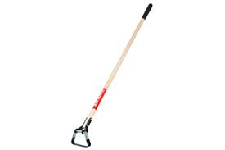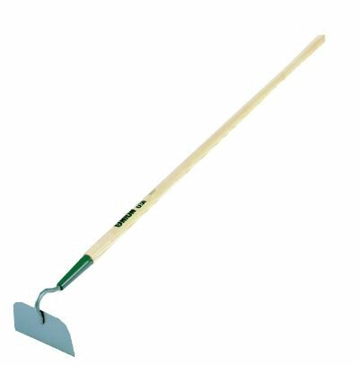Hoe
Irrigation Equipment
- Needed for weed control and to cover seeds after planting
- Can also use to make a small trench in which to plant the seeds
- Should be sharp and shiny so the soil does not stick to it.
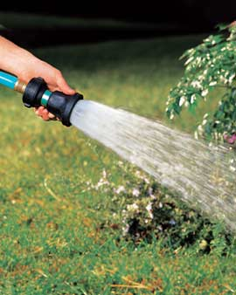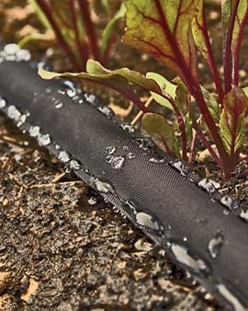
Rake
- For most gardeners, a hose and a nozzle attached to an outside water source is sufficient.
- If you have the time and are willing to exert some labor, a drip irrigation system attached to a timer is even better.
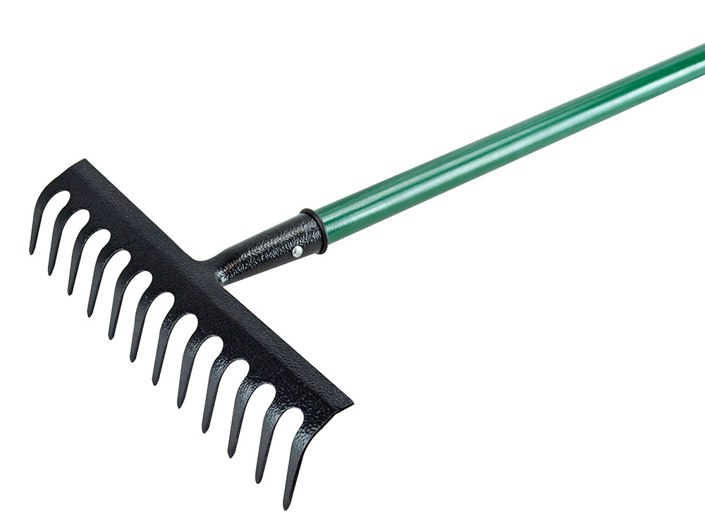
Shovel or Spade
- Used to even out the soil after turning it.
- It can also be used to loosen the surface soil crust that can form after a heavy rain.
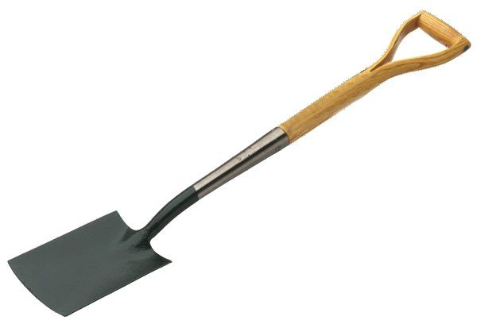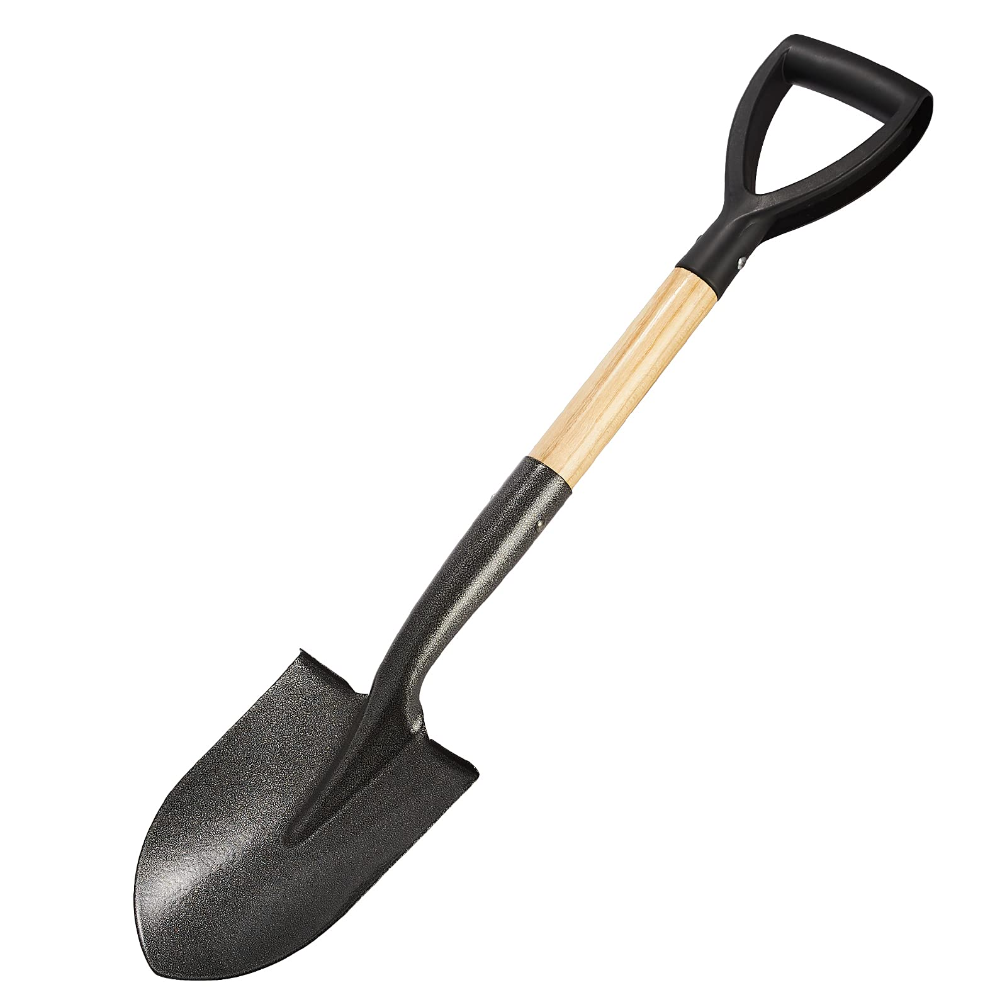
Trowel
- Used in both spring and fall to turn the soil and add organic material or other amendments
- Also used to harvest large root crops such as potatoes, rutabagas, and turnips
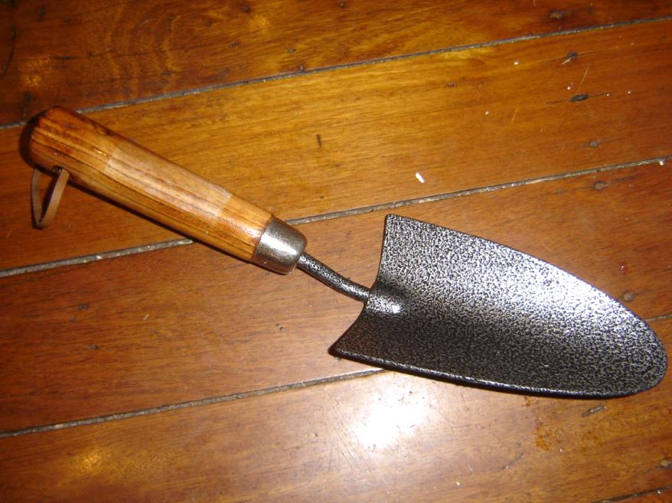
String, Stakes, and Measuring Devices
- A handy tool with a wide variety of uses
  - Digging holes for transplants
  - Remove excess soil from other equipment
  - Loosen soil around plants for ease of harvest
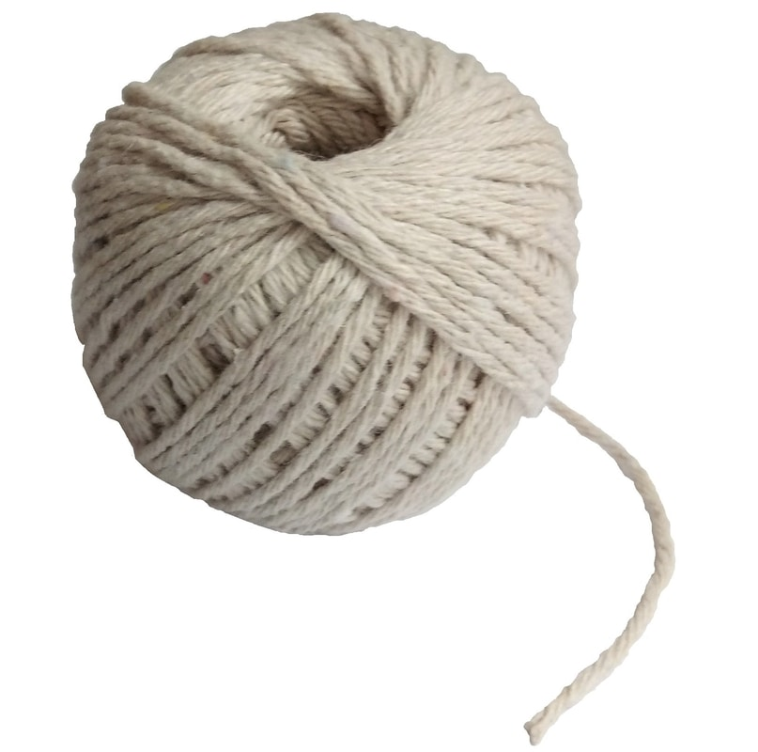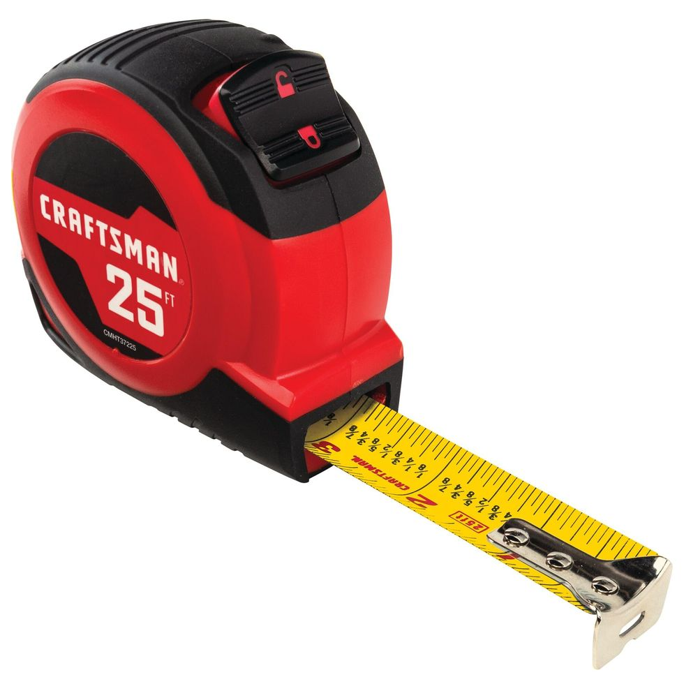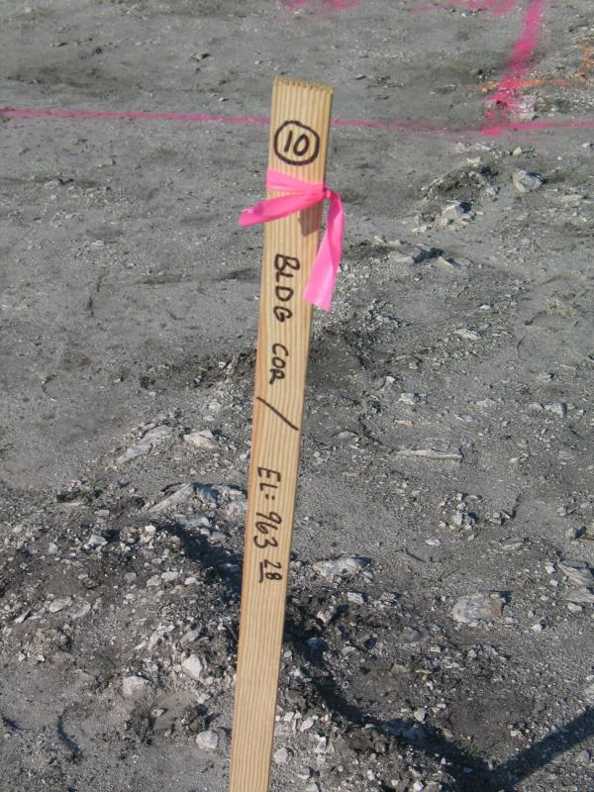
Sprayer or Duster
- Used for identifying the vegetables planted and their location
- Also handy for creating evenly spaced rows
- Stakes and strings can also be combined to make a trellis for vining crops like cucumbers or peas
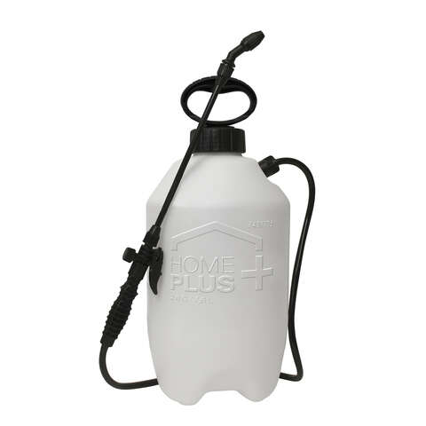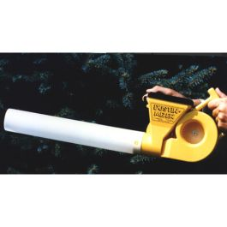
Hand Cultivator
- For applying pesticides
  - Using a duster or an aerosol can is one of the most economical pesticide application methods
- After using a sprayer, it should be rinsed, turned upside down, and allowed to dry completely
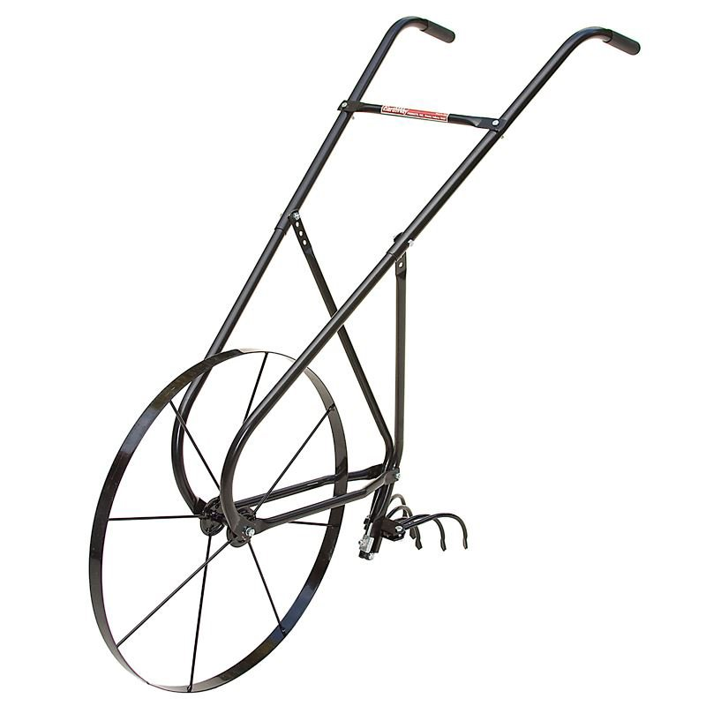
Seeder
- Can save time and effort when used for weed control in large gardens
- Also helpful for loosening soil crust to improve water penetration
- Also useful for digging deep trenches to plant potatoes or other root crops
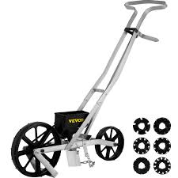
Fertilizer Application Device
- If you have a large garden, your back will thank you if you use a seeder
- Many are adaptable to seeds of different sizes
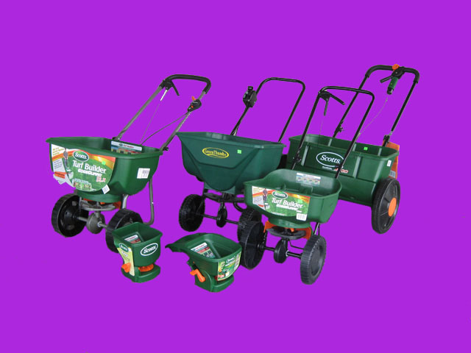
Rotary Tiller
- For a small garden, hand application of fertilizer is sufficient
- For larger gardens, applying fertilizer with a spreader will be quicker and easier and will apply the material more uniformly
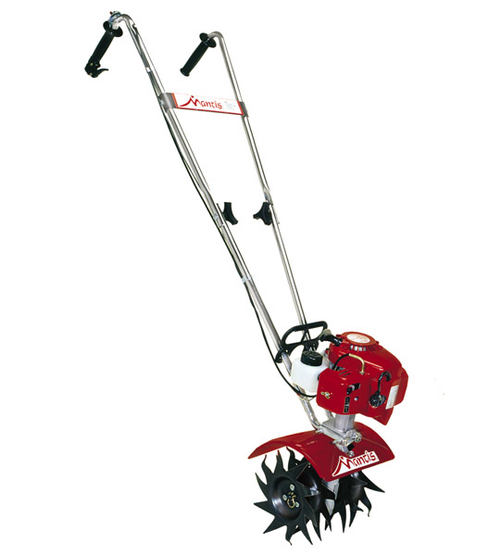
Chipper Shredder
- For large gardens, this is a quicker and easier way to loosen soil and prepare it for planting
- If you plan to use it to till between rows, you will need at least 16-30 in of space between your rows
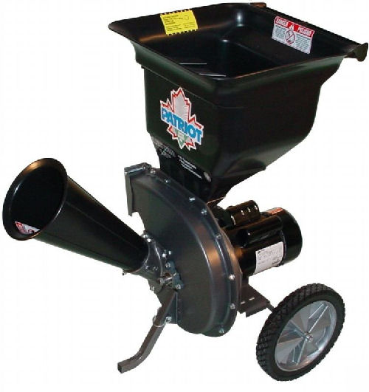
Soil Composition
Three Types of Mineral Soils
- A useful device for grinding limbs, leaves, and other large organic objects into material for a compost pile

Soil Type | Characteristics
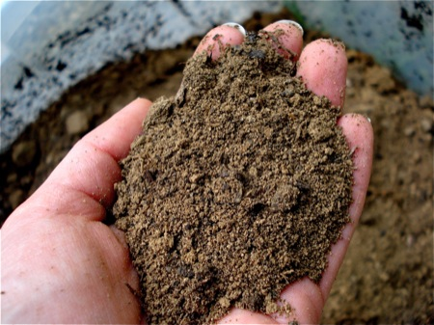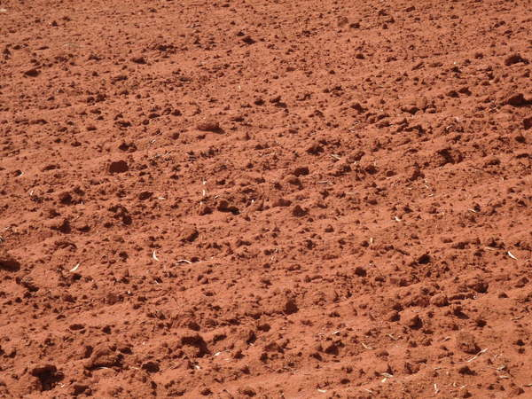  Sandy Soil  Loam Soil | - Contain <15% silt or clay  - Well-aerated  - Dry out and warm up quickly  - Low in fertility
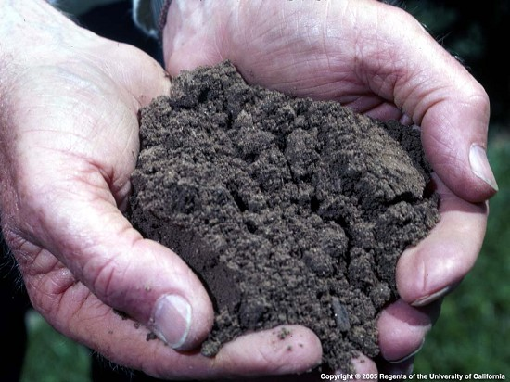 | - Contain <20% clay, 30-50% silt, and 30-50% sand  - Ideal for most vegetables
Clay Soil | - Contain 20-30% clay  - Retain water and dry slowly; difficult to cultivate properly  - Poor root growth due to small air spaces  - Crust easily, reducing plant growth, since they have difficulty breaking through the surface

Questions? Contact Me

